# **Exercise 1 - Configuring Accessibility Options**

Ease of Access, also known as Accessibility Options in earlier versions of Windows, is a set of settings that allows a Windows computer to accommodate users with physical limitations.

Receiving system notifications, display properties, mouse, keyboard, and audio settings are just a few of the accessibility options available when it comes to how a user interacts with Windows 11.

The Ease of Access Center can be found in either the Settings or the Control Panel windows. Options in Ease of Access are configured per-user and on a piecemeal basis, so they won't affect other users on the same Windows 11 PC.

In this exercise,

1. Setting Up Accessibility Options
2. Manage Accessibility Settings for Another User

## **Topology**

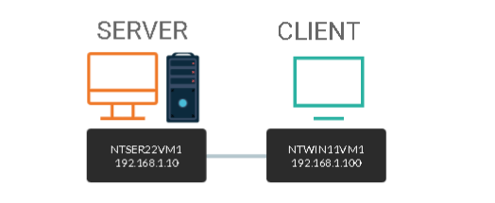

DOMAIN = networktute.com

NTSER22VM1 = Windows Server 2022 – Domain Controller

NTWIN11VM1 = Windows 11 – Domain Member

## **Prerequisite**

* *VMware Workstation 16 Pro*
  + When making this tutorial, we used the “Windows Server 2019” VM Template and “Windows 10 & later” VM Template. Since VMware didn’t have the updated templates.
* *Microsoft Windows Server 2022*
* *Microsoft Windows 11*

## **Task 1:**

The Ease of Access Center can be found in the Control Panel window or under Settings. On these settings, you can specify display attributes, audio settings, and other hardware settings for the user.

In this task, we will configure accessibility settings for the administrator of the system.

**Step 1:**

Ensure you are connected to **NTWIN11VM1**. Click in the **Type here to search** box and type: ***control***

On the **Best match** pop-up menu, select **Control Panel.**

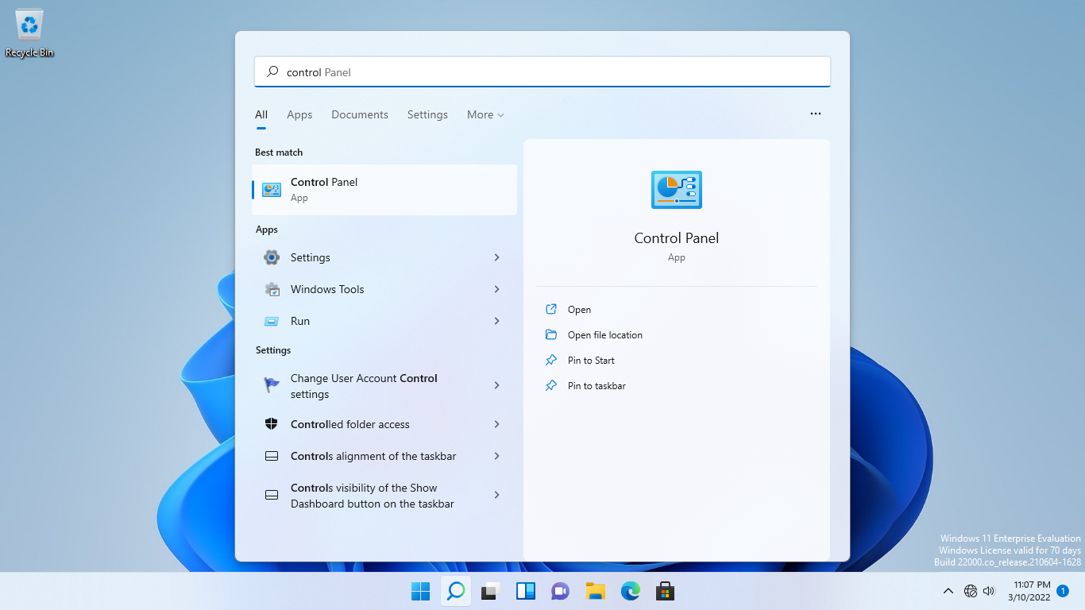

**Step 2:**

Click the **View by** drop-down and select **Small icons.**

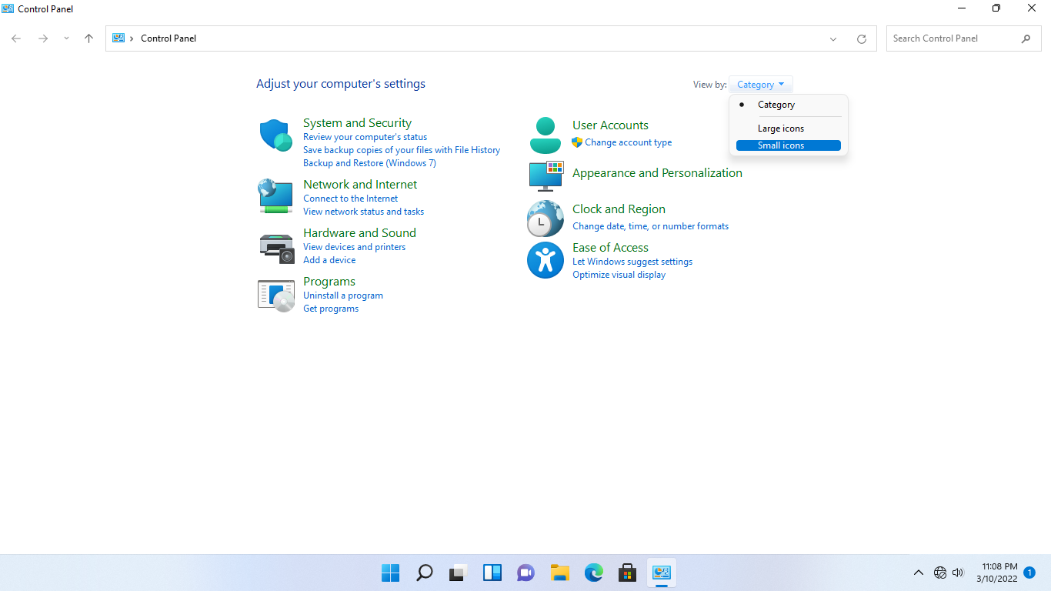

**Step 3:**

On the **Control Panel** window, click **Ease of Access Center.**

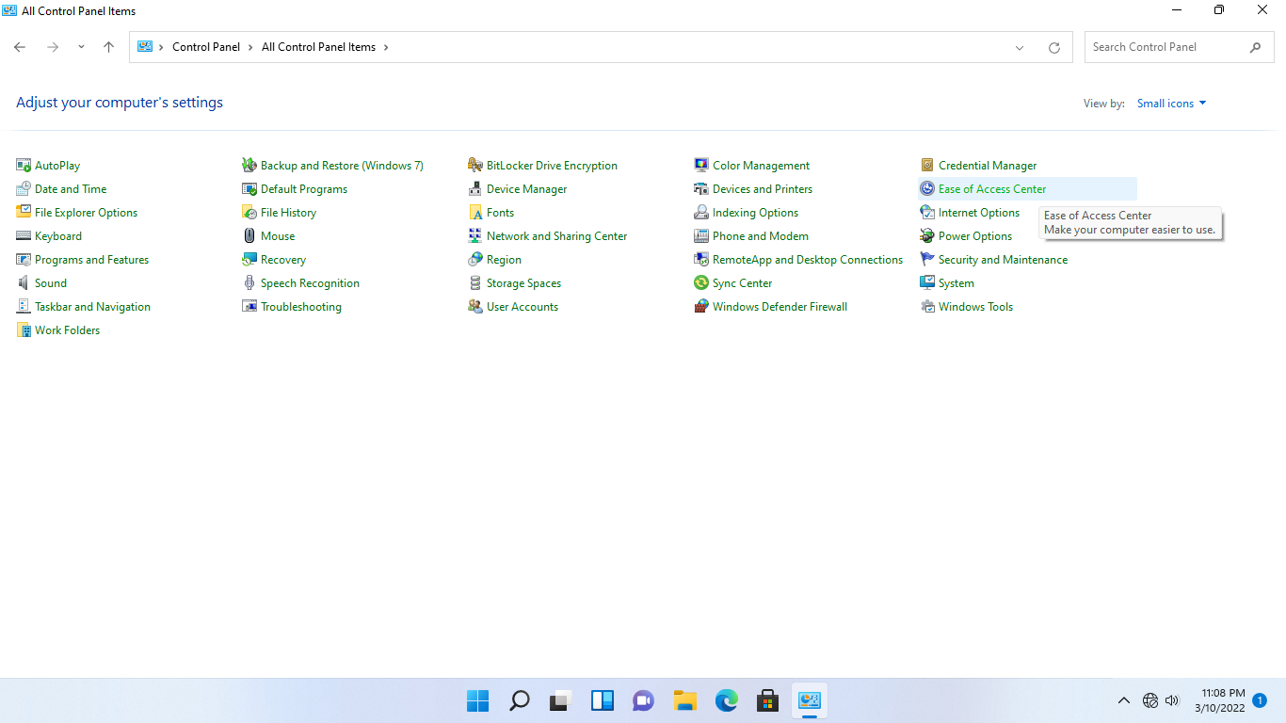

**Step 4:**

Under the **Ease of Access Center** section, click **Make the computer easier** to see to optimize the visual display.

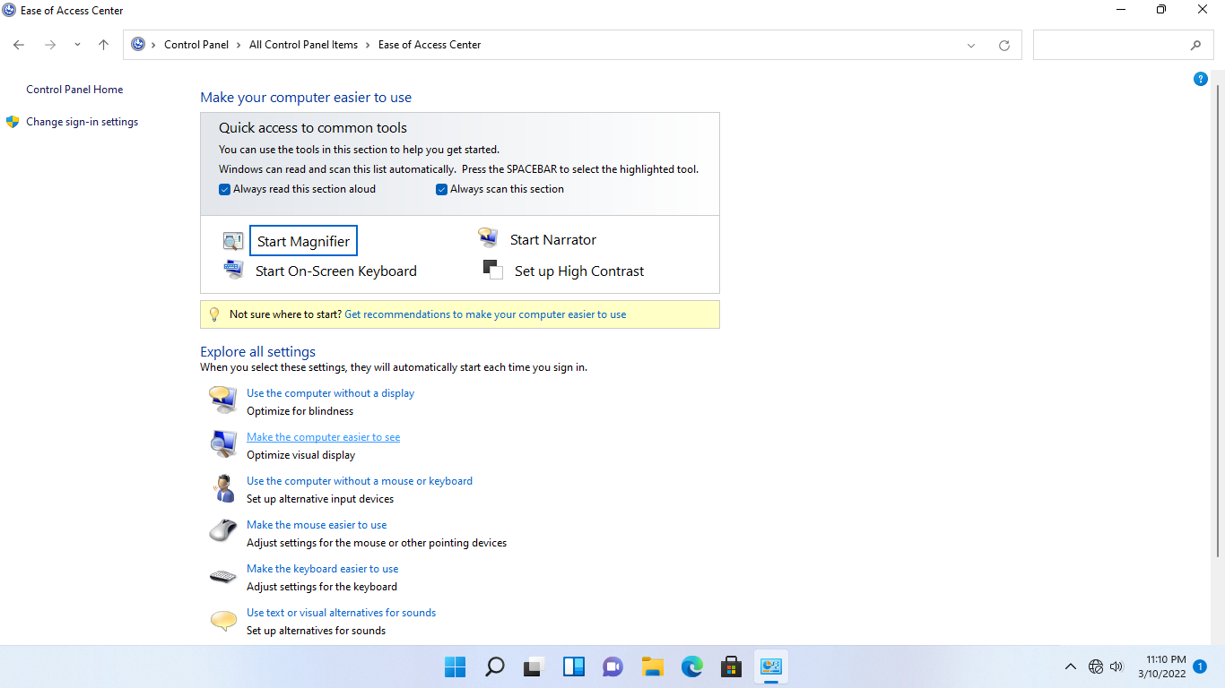

**Step 5:**

On the **Make the computer easier to see** page, tick the **Turn on Magnifier** and **Make the focus rectangle thicker** checkboxes.

Click **OK**.

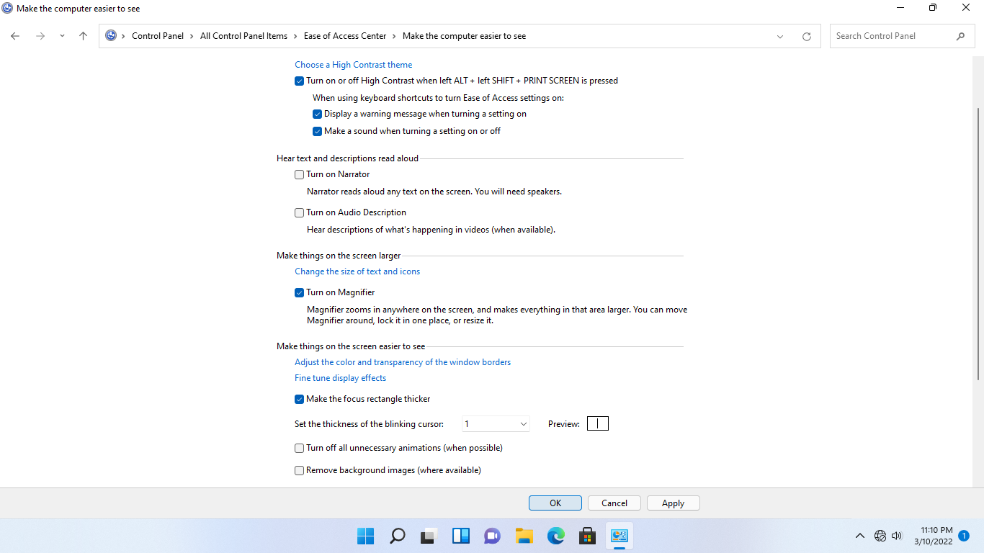

**Step 6:**

Notice the change in the size of the screen as every aspect of the interface is magnified.

Note that the mouse may become difficult to use when the screen is magnified, so move the mouse slowly.

This **Magnifier** feature is useful, for example, if you are making a presentation and you want to emphasize a section of the screen to the audience.

The **Magnifier** toolbar appears floating at the top of the window. You may need to scroll up to the top of the page to view it

You can click the **[X]** button on the toolbar to close the **Magnifier** tool.

|  |
| --- |
| **Note**: Using the **Magnifier** toolbar, click “-“to zoom out back to 100%. Note that the Magnifier setting will still be enabled until you close the Magnifier tool. |

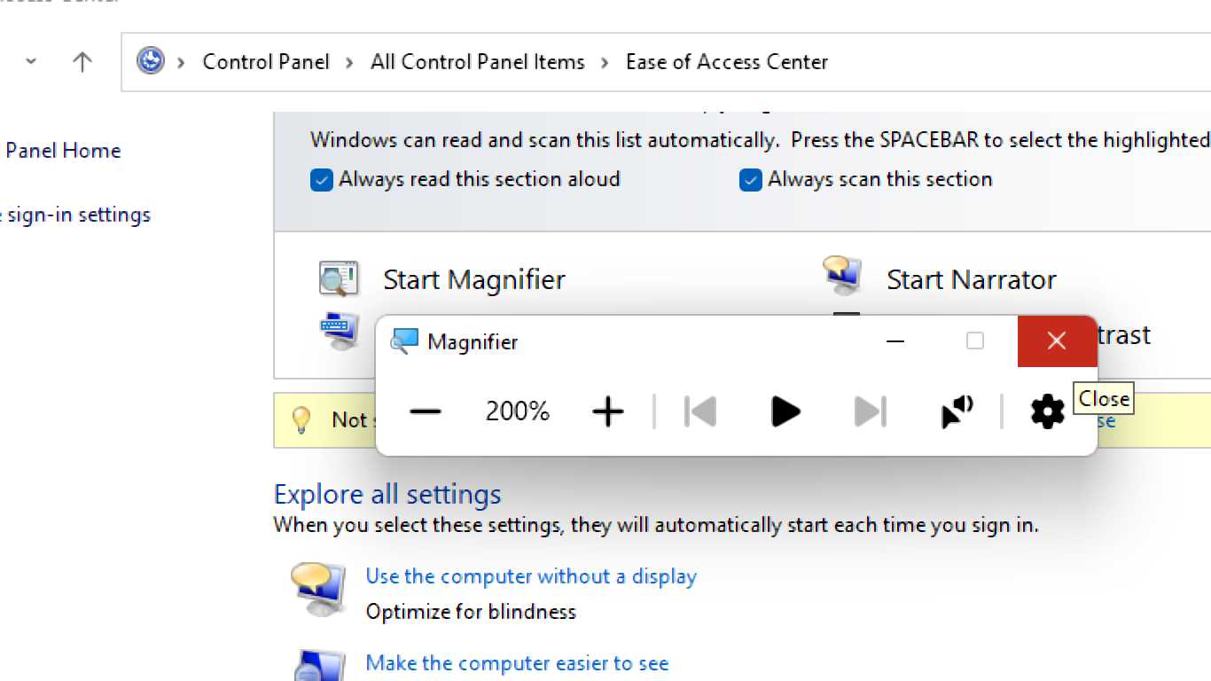

**Step 7:**

Once the **Magnifier** tool has been closed, you will be back on the **Make your computer easier to use** page with the default magnification.

Now, under the **Explore all settings** section, select **Use the computer without a mouse or keyboard**.

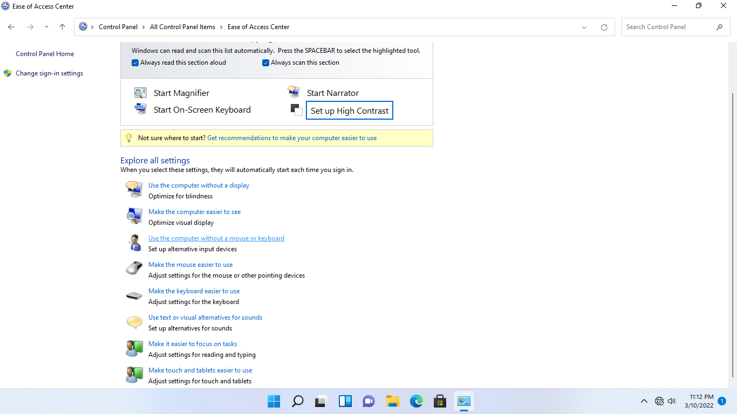

**Step 8:**

On the **Use the computer without a mouse or keyboard** page, tick the Use **On-Screen Keyboard** checkbox.

Then click **OK**.

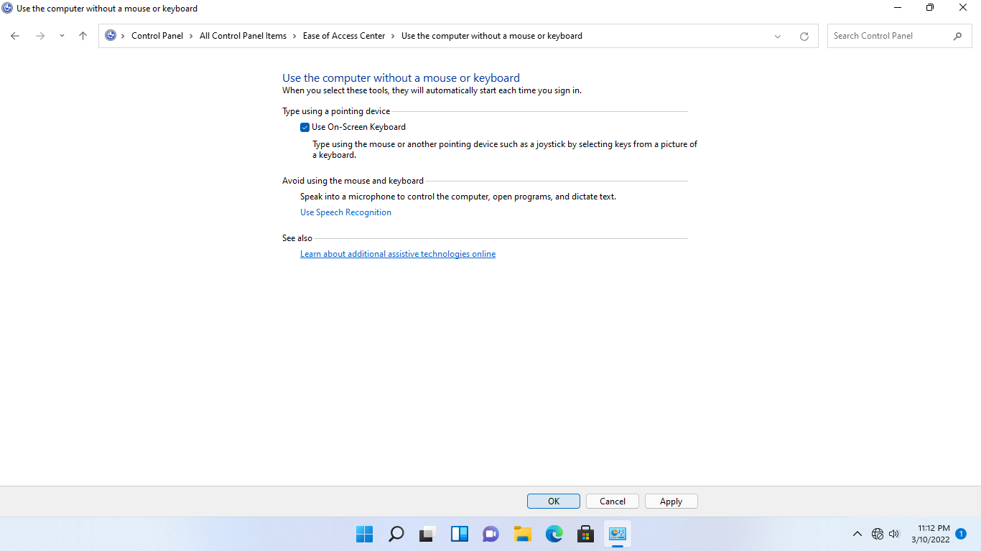

**Step 9:**

There will be a slight time lag before the on-screen keyboard appears.

You will then be directed back to the **Make your computer easier to use** page.

From the on-screen keyboard, click the **Windows** logo to bring up the **Start menu.**

You may need to click the **Windows** logo twice on the keyboard as there will be a slight time lag before the **Start** menu appears

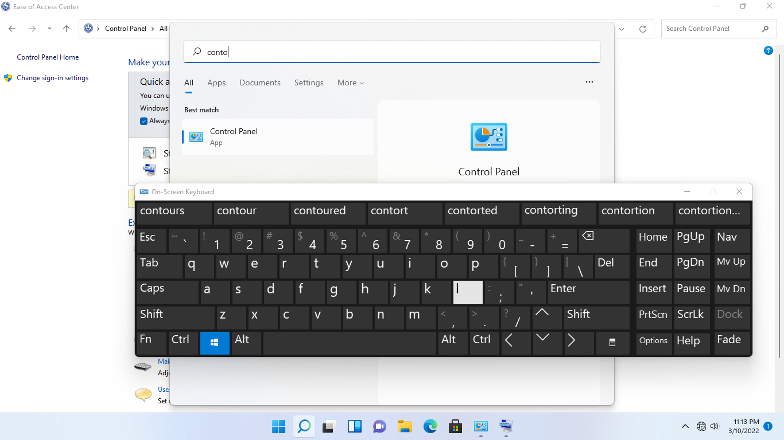

**Step 10:**

Now let’s switch off the **On-Screen Keyboard** feature.

Go back to the **Use the computer without a mouse or keyboard** page, untick the **Use On-Screen Keyboard** checkbox.

Then click **OK.**

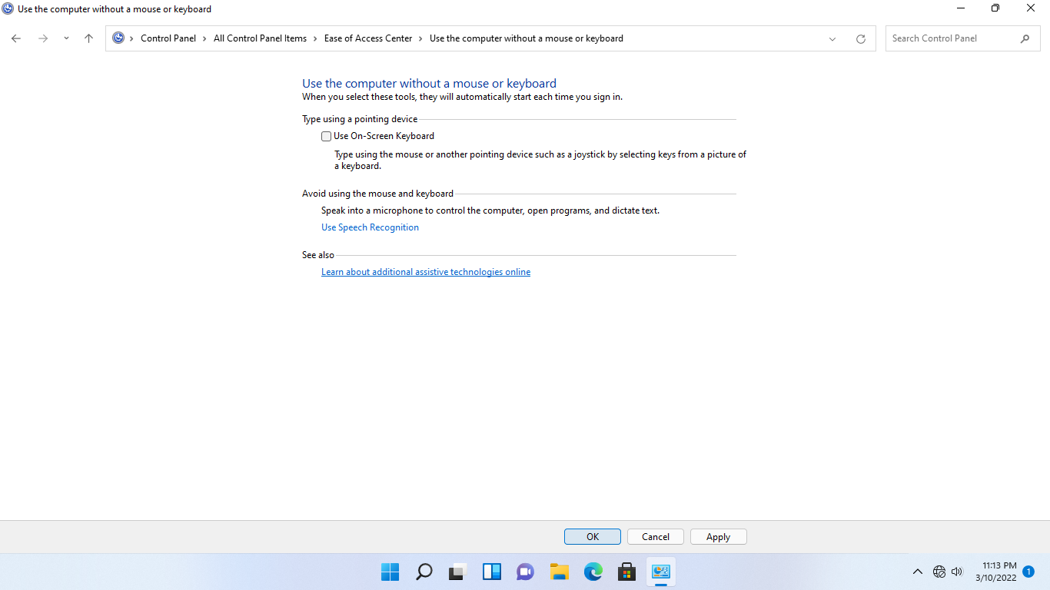

**Step 11:**

Back on the **Make your computer easier to use** page, under the **Explore all settings** section, click **Make the mouse easier to use.**

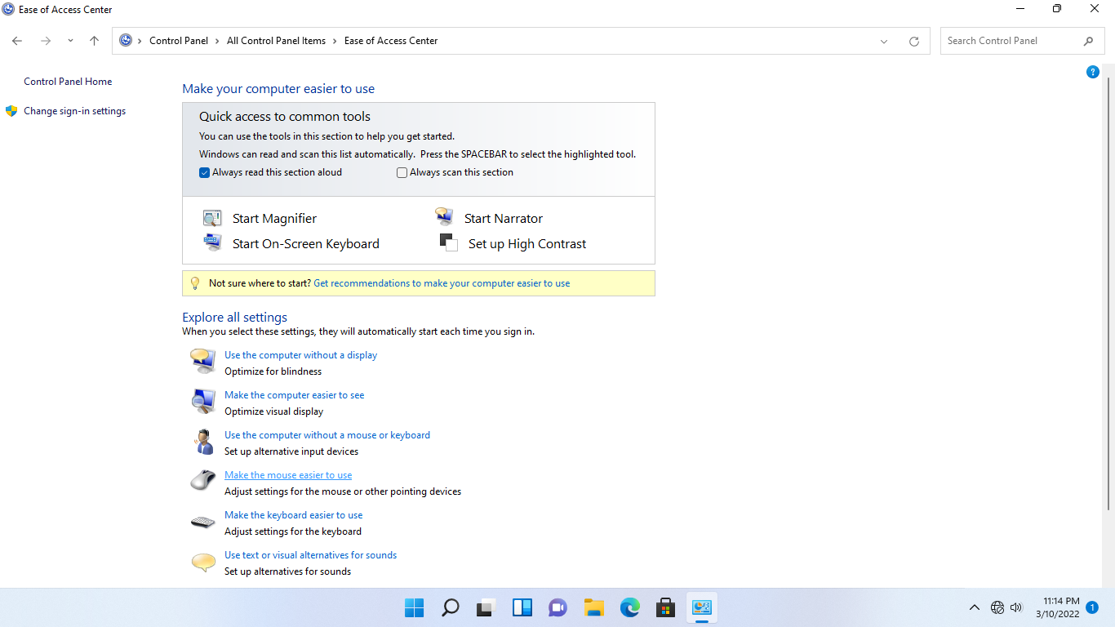

**Step 12:**

On the **Make the mouse easier to use** page, under the **Mouse pointers** section, select **Extra Large White.**

Under the **Control the mouse with the keyboard** section, tick the **Turn on Mouse Keys** checkbox.

Click **Apply**.

Scroll down and click the **Set-up Mouse Keys** web link.

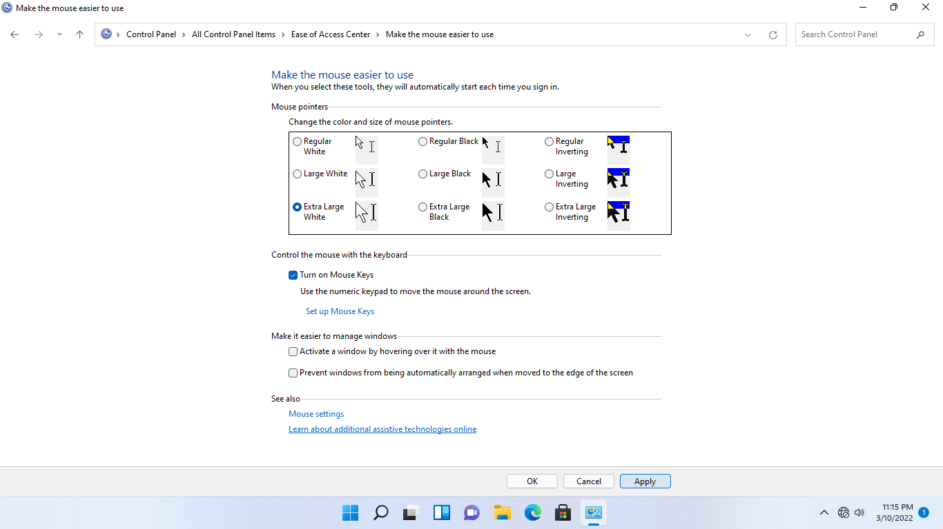

**Step 13:**

On the **Setup Mouse Keys** page, ensure that the **Turn on Mouse Keys** checkbox is ticked.

Click **OK.**

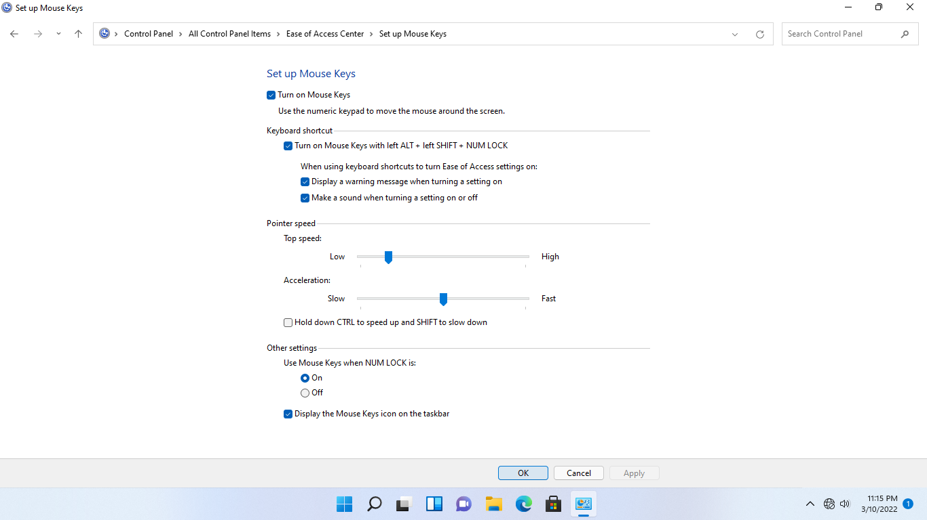

**Step 14:**

Back on the **Make the mouse easier to use** page, click **OK**.

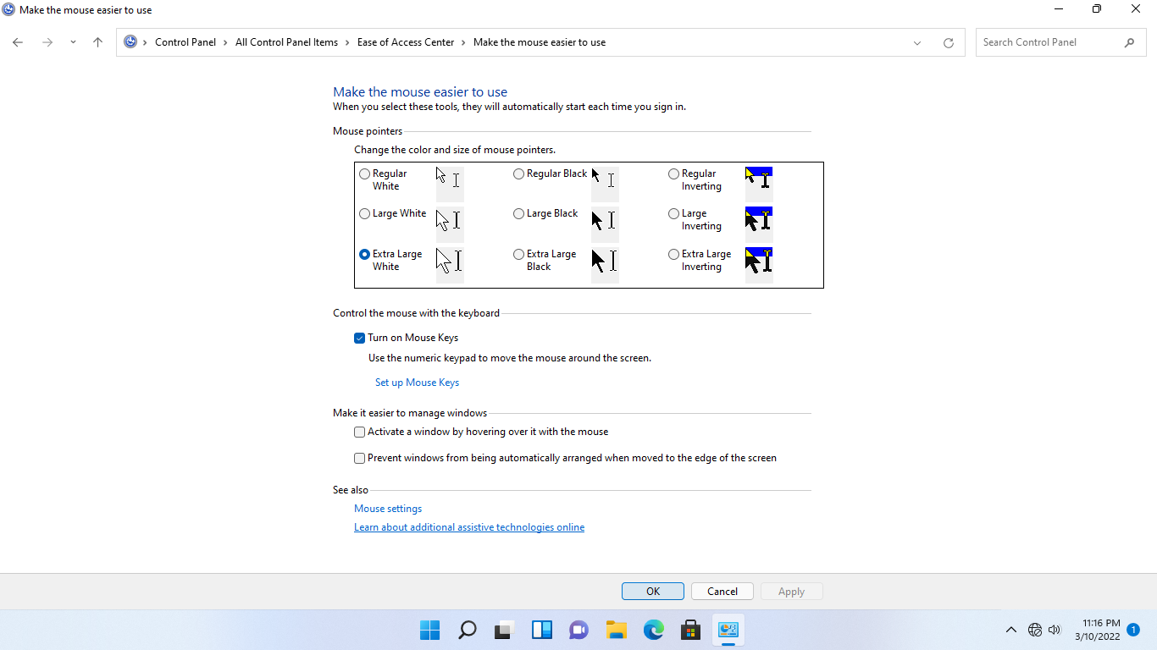

**Step 15:**

You will be directed back to **Make your computer easier to use**.

Click the up arrow in the system tray and observe that the **Mouse Keys** icon appears.

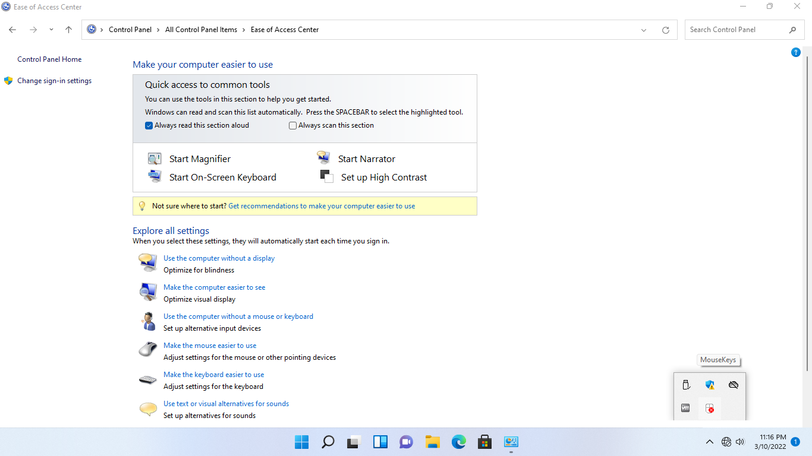

**Step 16:**

Click **Make the keyboard easier to use** web link.

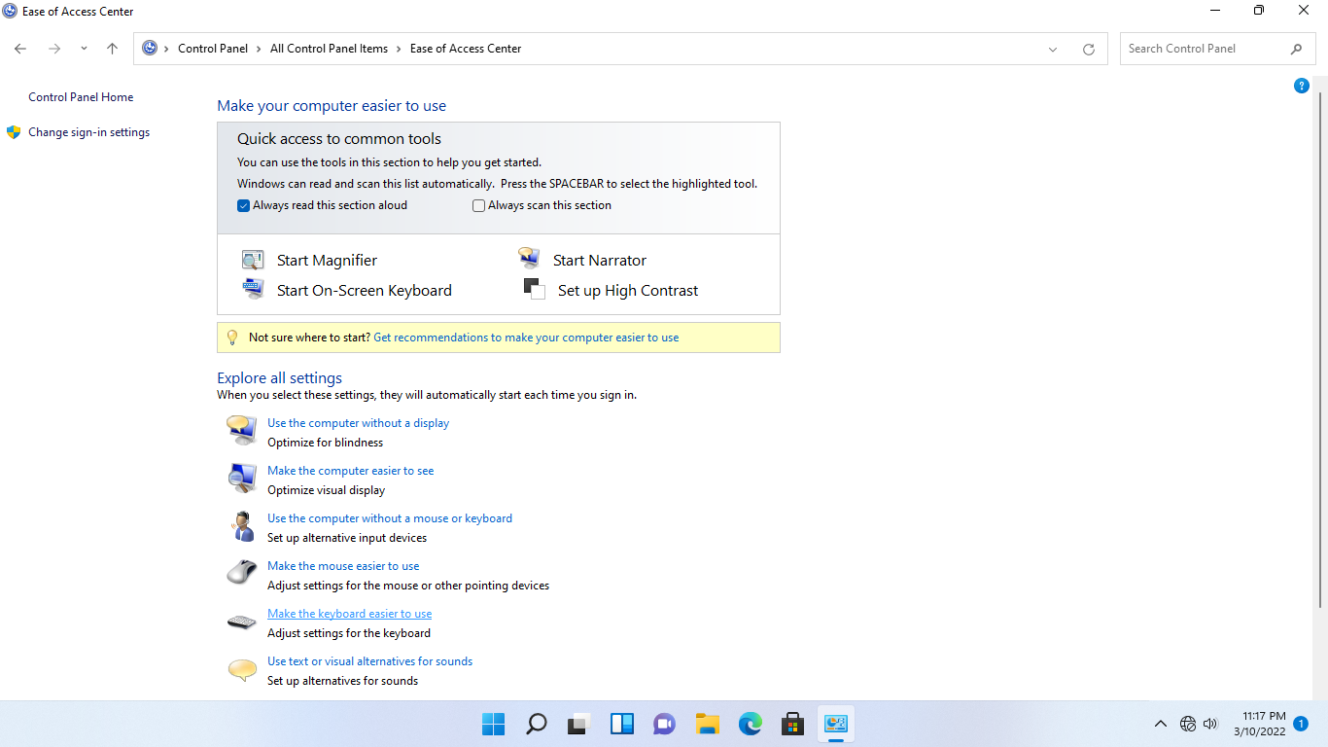

**Step 17:**

On the **Make the Keyboard easier to use** page, under the **Make it easier to type**, tick the **Turn on Sticky Keys** checkbox.

Click **Apply**. Then click **Set up Sticky Keys**.

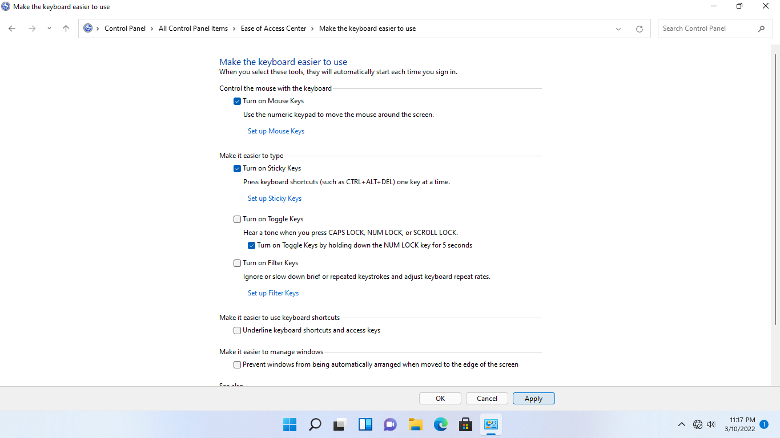

**Step 18:**

Observe that the **Sticky Keys** icon appears on the system tray.

Click **OK** to save changes.

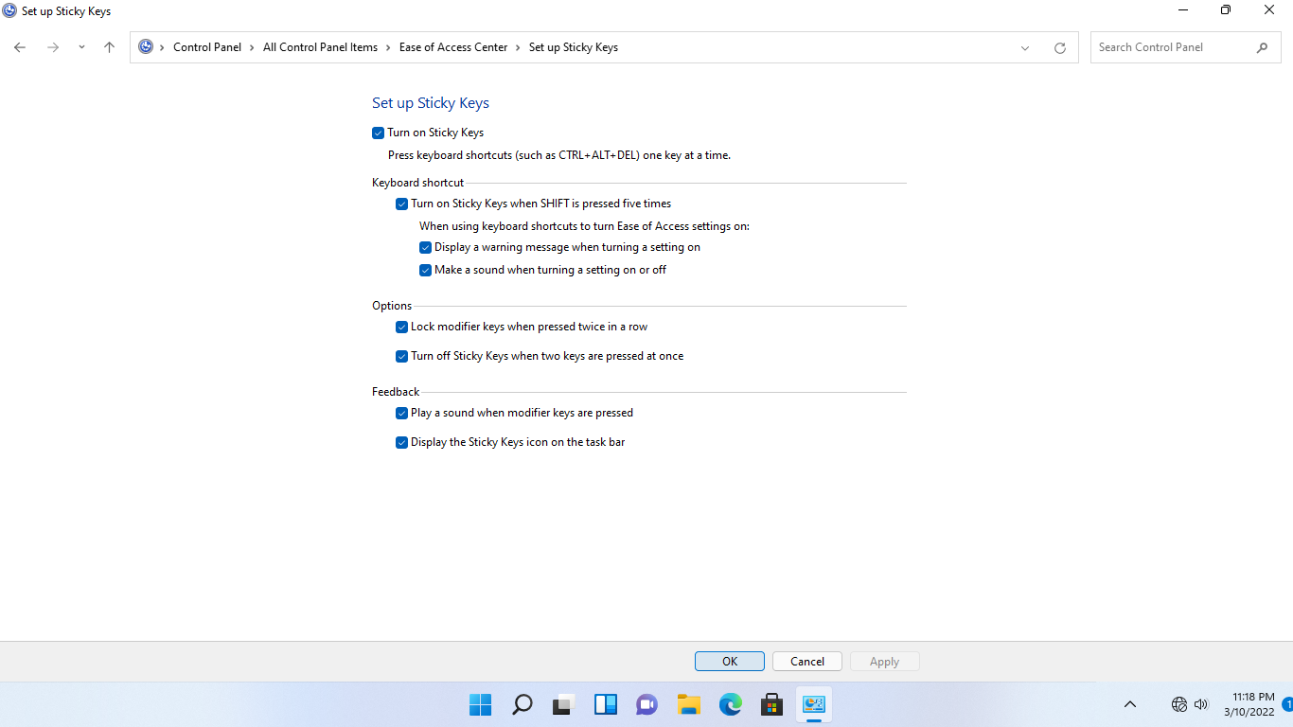

**Step 19:**

You will be directed back to the **Make the keyboard easier to use**.

Tick the **Turn on Toggle Keys** checkbox.

|  |
| --- |
| **Note**: You will not hear a sound from the lab device when you toggle keys like CAPS LOCK, NUM LOCK or SCROLL LOC. Sound is not available on a virtual machine used in this lab. |

Then tick **the Turn on Filter Keys** checkbox.

Click **Apply**.

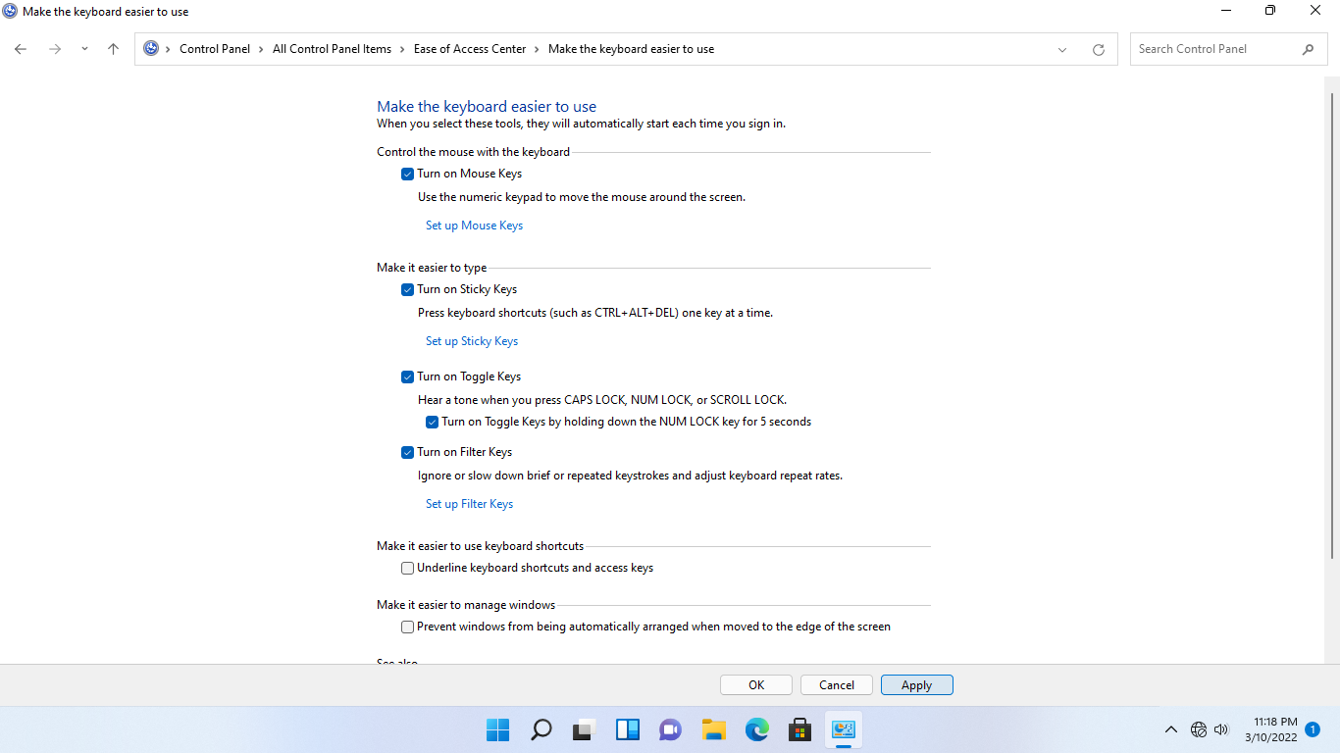

**Step 20:**

Then click **Set up Filter keys.**

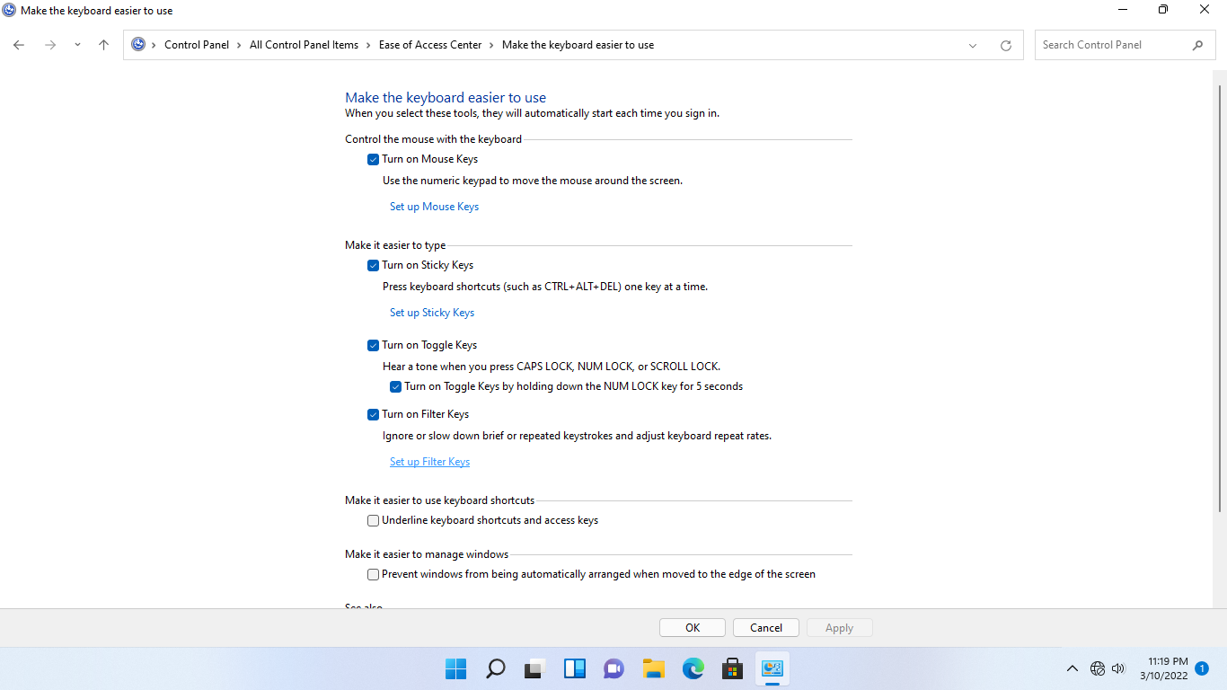

**Step 21:**

On the **Setup Filter Ke**ys page, the **Turn on Filter Keys** box is now ticked.

Verify that the **Turn on Repeat Keys and Slow Keys** option is selected.

Click in the **Type text here to test settings**. Enter the following text by holding each key down until the number appears on the screen: ***123***

|  |
| --- |
| **Note**: You may need to press and hold “**1**” before it appears in the box. This is the effect of turning on Filter keys on a computer |

Since you don’t want this feature to be enabled on this computer, untick the **Turn on Filter Keys** checkbox.

Click **OK.**

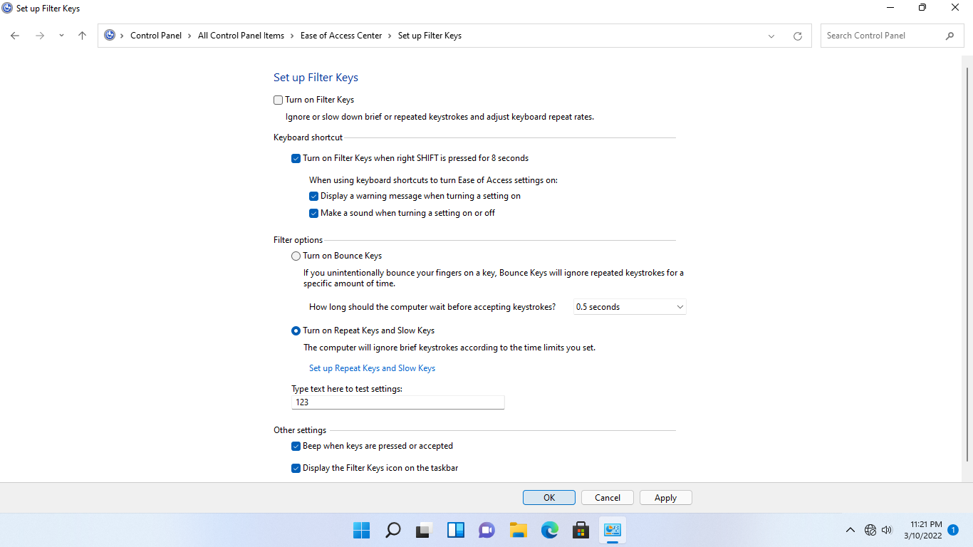

**Step 22:**

Back on the **Make the keyboard easier to use** section, untick the **Turn on Mouse Keys** checkbox.

Click **OK**.

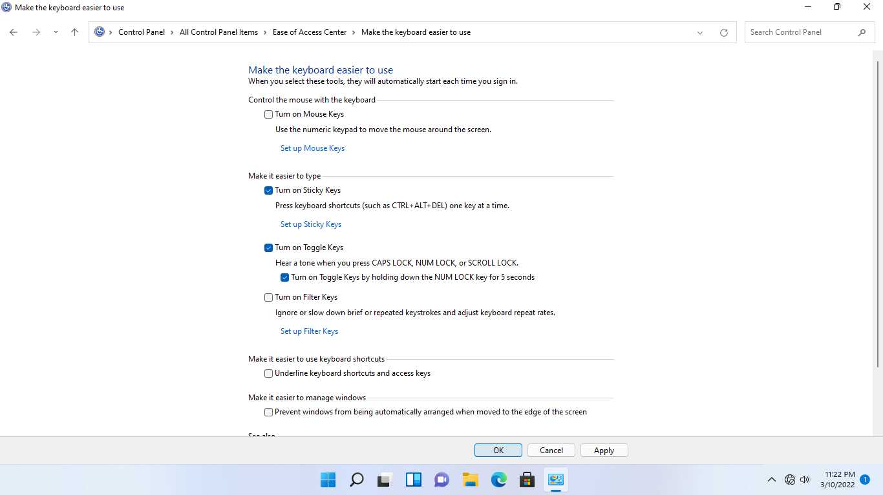

**Step 23:**

Back on the **Make your computer easier to use** section, under the **Explore all settings** section, click **Use text or visual alternatives for sounds**

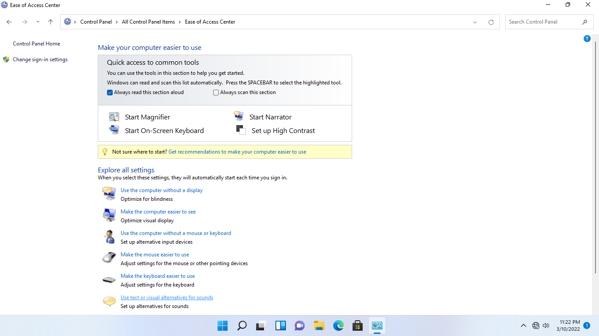

**Step 24:**

On the **Use text or visual alternatives for sounds** page, tick the **Turn on visual notifications for sounds** checkbox.

Then under the **Choose visual warning**, select **Flash desktop**.

Then click **OK**.

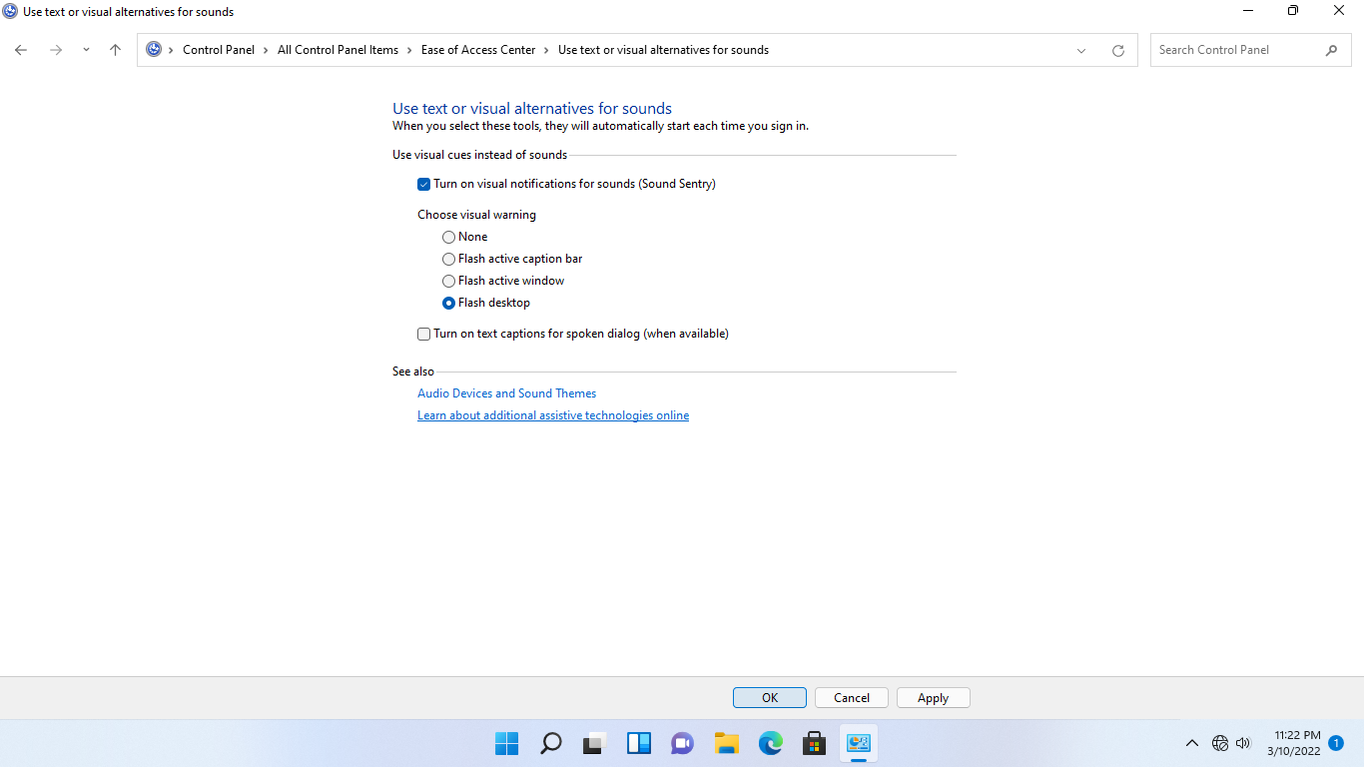

**Step 25:**

You are back on **Make your computer easier to use**.

To test the visual notification, you configured in the previous step, press the Caps Lock key on your keyboard.

For a brief moment, the desktop turns a different color and the window changes to a black background before going back to its usual color.

|  |
| --- |
| **Note**: If the visual notification does not seem to display, sign out and sign back in using the same Administrator account |

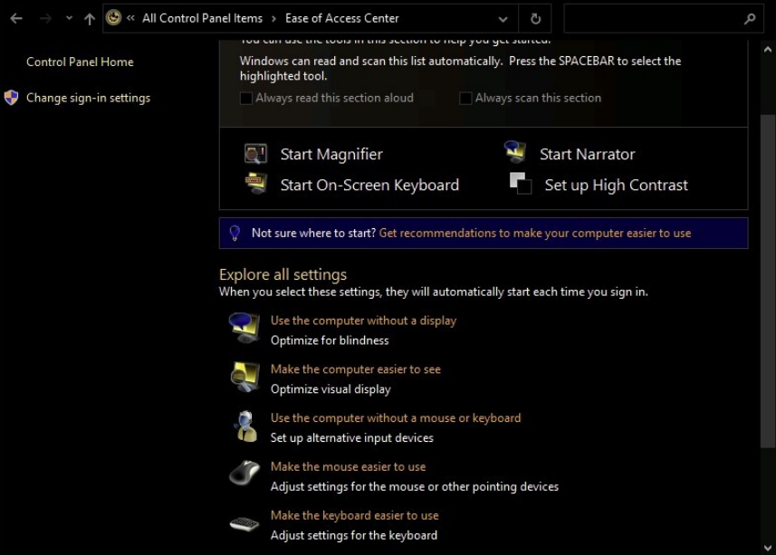

**Step 26:**

Since you don’t want this feature to be enabled on this computer, click **Use text or visual alternatives for sounds**

Then under **Choose visual warning**, select **None**.

Click **OK**.

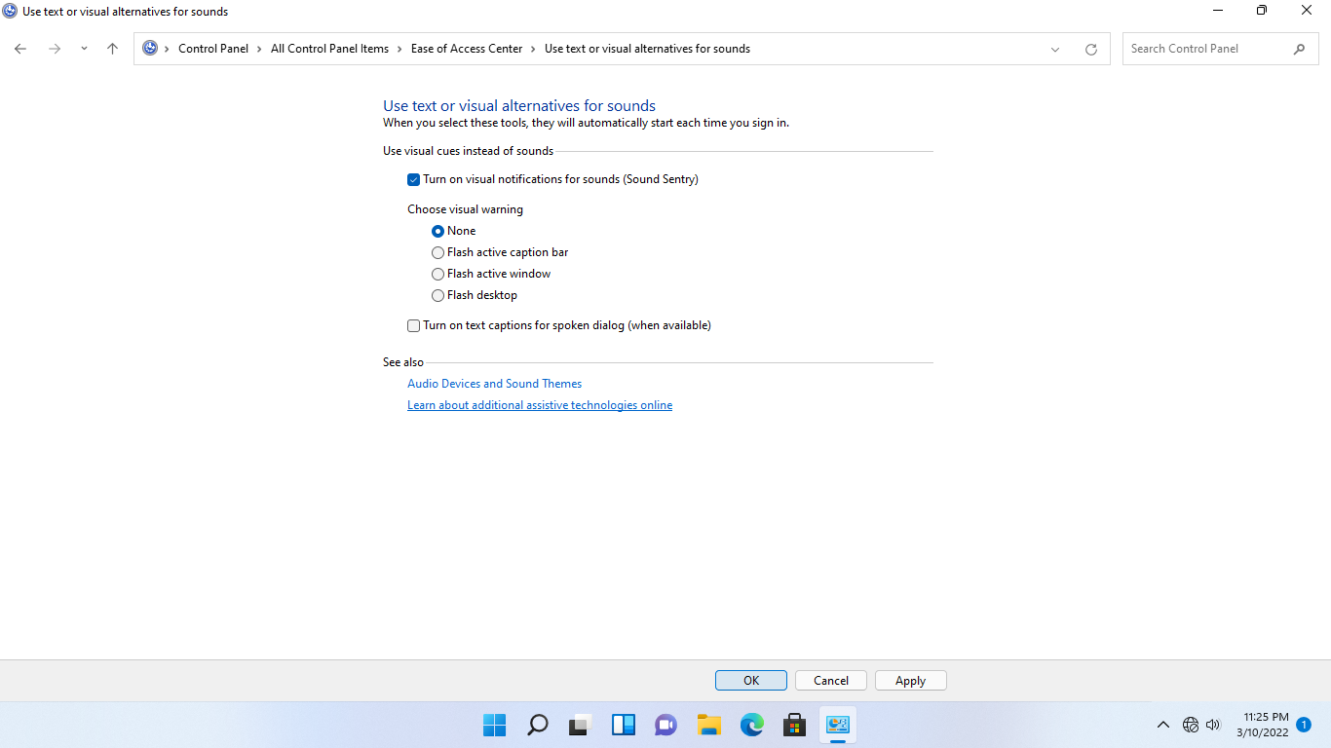

## **Task 2:**

Ease of Access or accessibility features in Windows 11 are controlled by the user.

In this task, we will test accessibility settings by signing in as another user account.

For this step, you will need to disable the **Server Auto login** feature. Click on the **Access your settings** cog on the Networktute toolbar. Switch **Server auto login** off. Click the **Access your exercise content** document icon to go back to your current task.

**Step 1:**

Connect to **NTWIN11VM1**.

Right-click the **Start** icon, click **Administrator** and select **Sign out.**

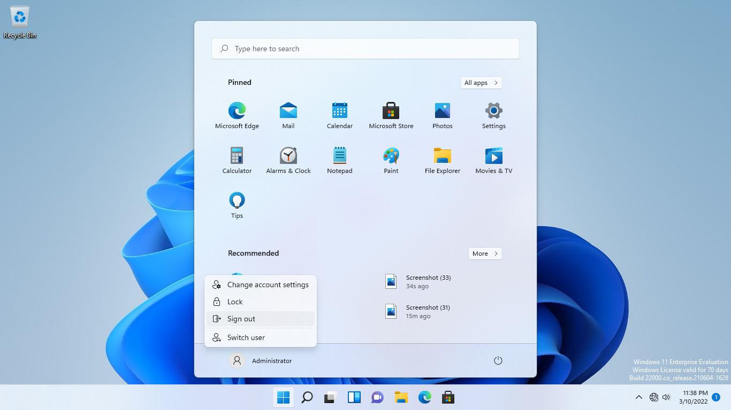

**Step 2:**

Click the **reconnect** icon from the lab device menu bar above to reconnect or alternatively press **F5**. You may need to do this a few times.

On the user sign-in screen, click **Other user.**

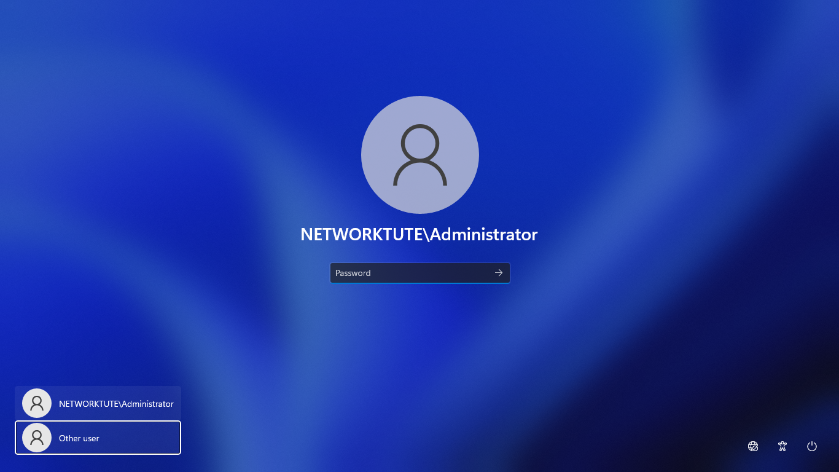

**Step 3:**

On the sign-in page, click in the User name text box and type: ***ntclient***

In the Password text box, type: ***networktute@1***

Press **Enter**

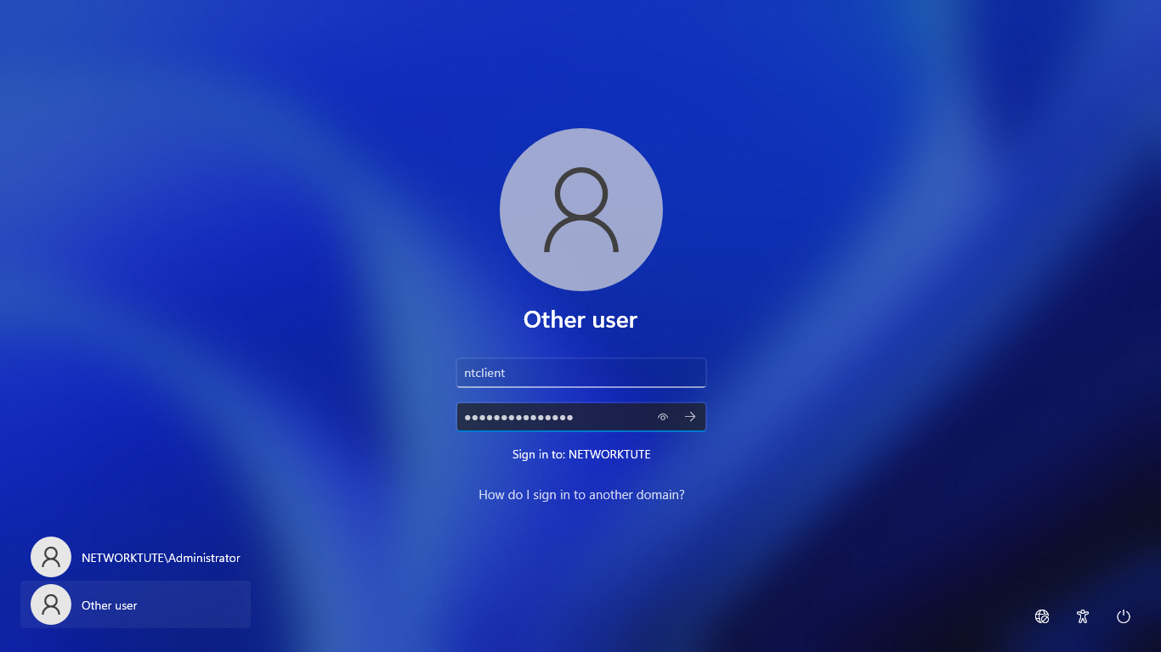

**Step 4:**

Another option to set ease of access options for a user is by using **Settings**.

Click the **Start** icon and select **Settings**.

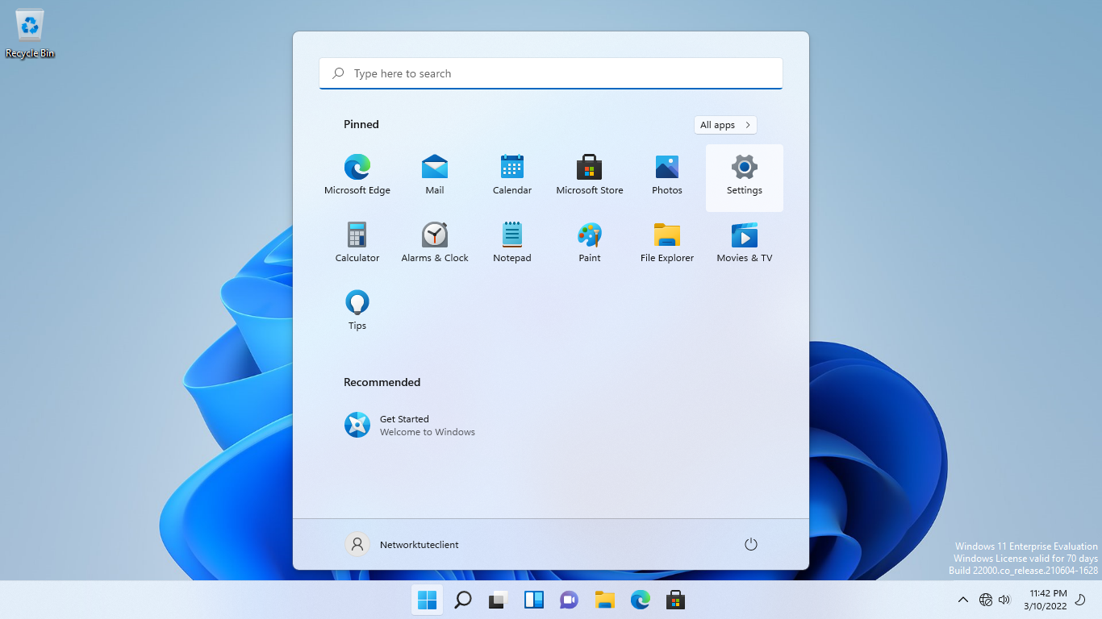

**Step 5:**

From the **Settings** window, search **Accessibility.**

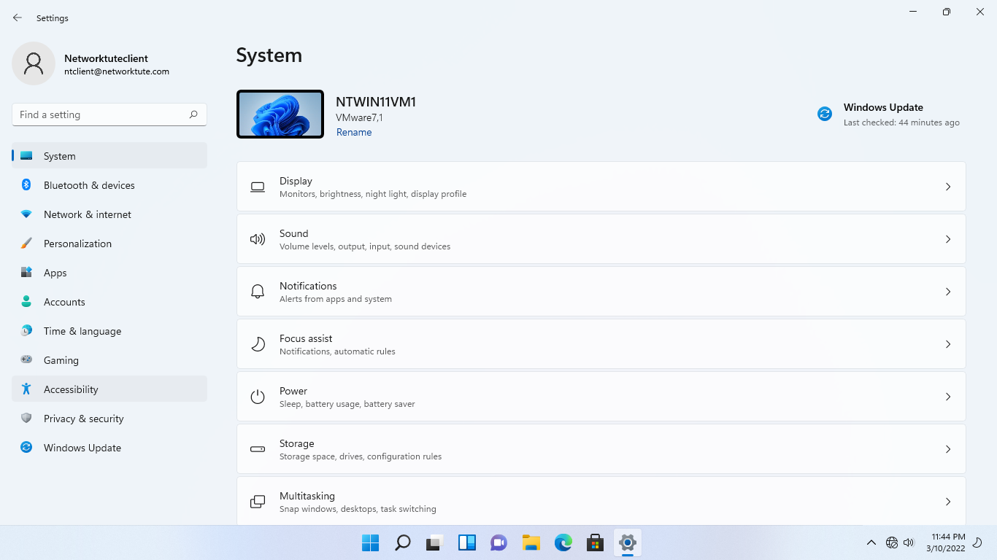

**Step 6:**

On the **Accessibility** left pane, scroll down the menu and click **Keyboard.**

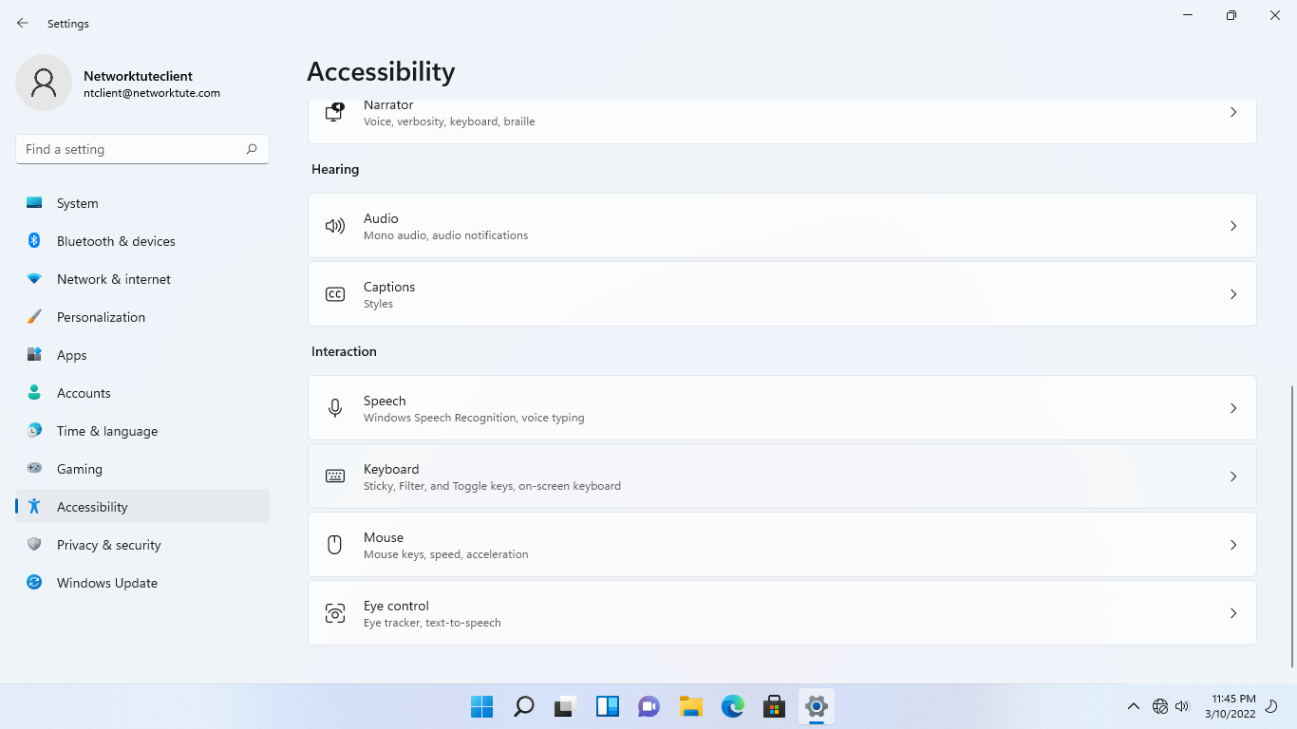

**Step 7:**

From the **Keyboard** section, scroll to the **Use Toggle Keys** section and set the slider switch to **On.**

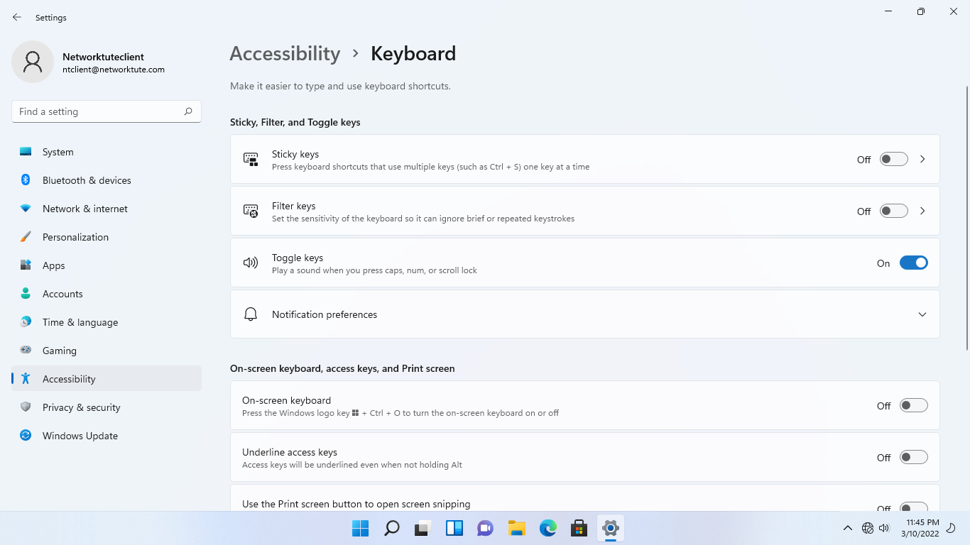

## **Task 3:**

Accessibility features in Windows 10 are controlled by the user. In this task lets configure Visual alert for audio notification.

In this task we are using **NTWIN10VM1.**

**Step 1:**

Click in the Find a setting search box in the top right-hand corner of the Keyboard page and type: ***visual***

Click **Show a visual alert for audio notifications**.

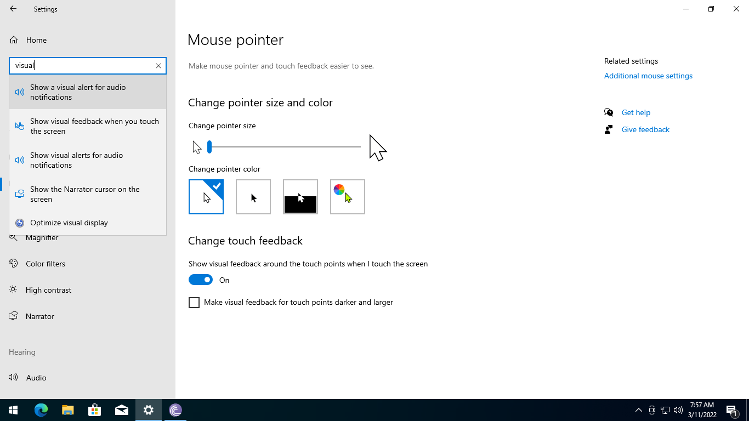

**Step 2:**

On the **Audio page**, under **Show audio alerts visually**, click the drop-down arrow and ensure the **Flash the entire screen** option is selected.

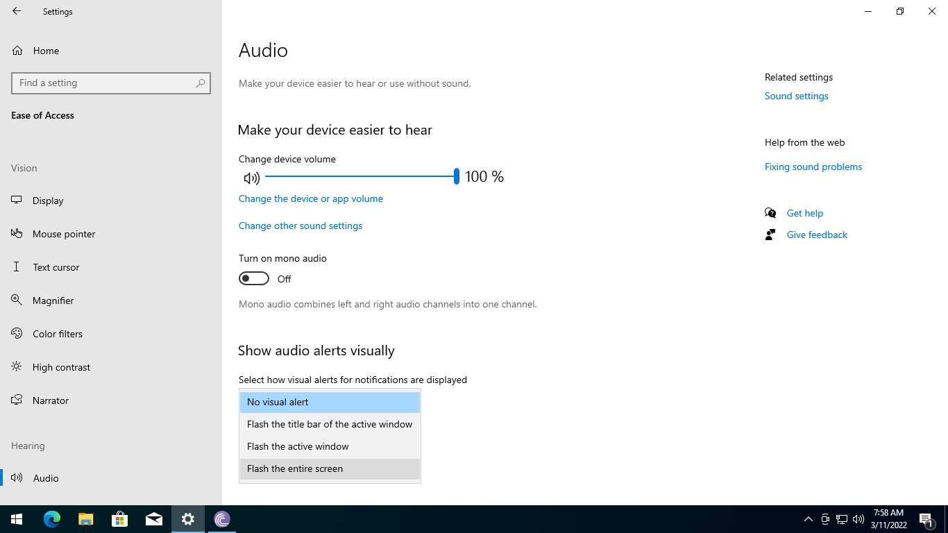

**Step 3:**

Now press the **Caps Lock** key on your keyboard.

The desktop will light up in a dark color for a brief moment and then go back to its correct color shade

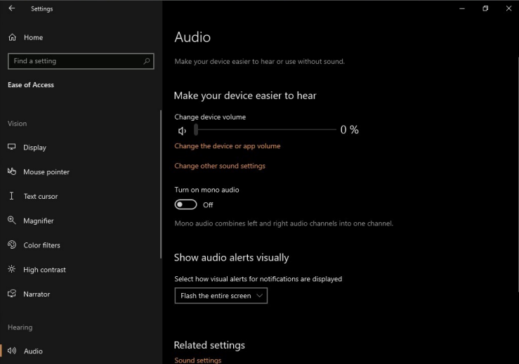

**Step 4:**

Since you don’t want this feature to be enabled on this computer, on the **Audio page**, under S**how audio alerts visually**, click the drop-down arrow and ensure the **No visual alert** option is selected

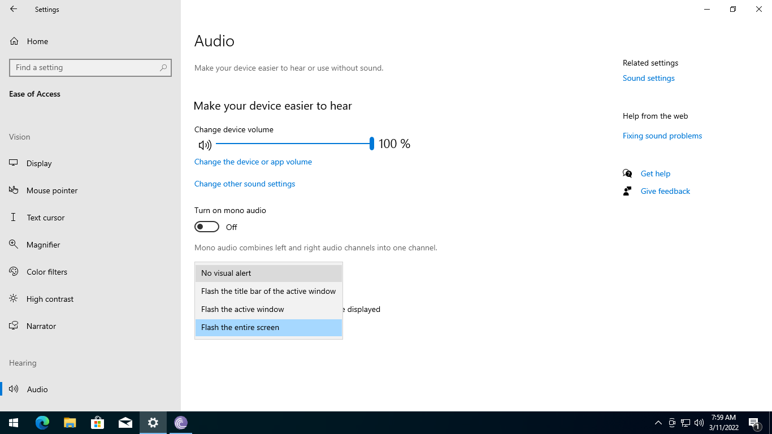

**Step 5:**

Close the **Settings** window.

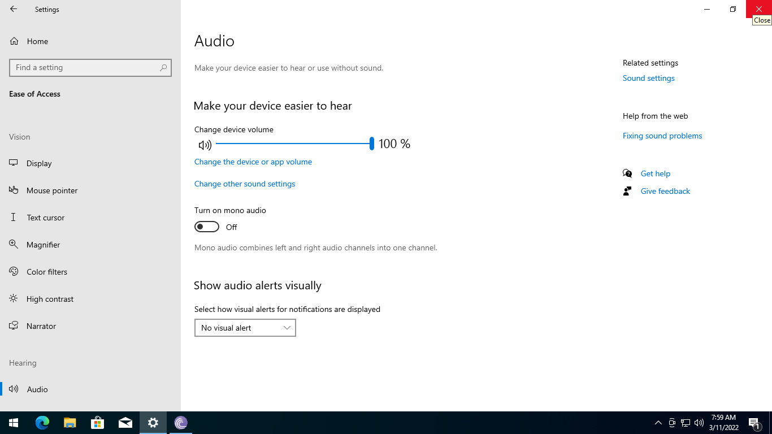

**Step 6:**

Right-click the **Start** icon, click **Profile** and select **Sign out**.

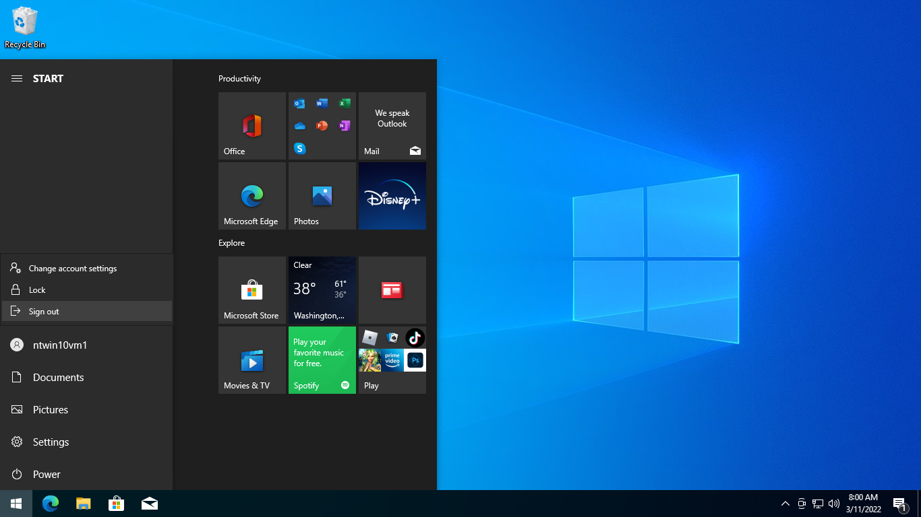

**Step 7:**

Click the **reconnect** icon from the lab device menu bar above to reconnect or alternatively press **F5**. You may need to do this a few times.

When you reconnect to **NTWIN11VM1**, ensure you have been automatically signed in as the **Administrator** user.

|  |
| --- |
| **Note**: You can do this by clicking the **Start** menu. |